

ITA0330-Mobile Computing

Name: T. Dharani Devi Reg no:192425036

Slot: D Course Name: Mobile Computing

Experiment 8: Public Land Mobile Network (PLMN) Infographic
Aim: To create an infographic explaining the concept of Public Land Mobile Network (PLMN) using Figma.
Procedure:
- Open Figma and create a new design file.
- Create a frame for the PLMN infographic.
- Add icons representing mobile users and mobile devices.
- Include base stations and the radio access network.
- Add core network components and subscriber authentication.
- Connect the components using arrows and explanatory labels.
- Apply suitable colors and icons to make the infographic informative.

Output:
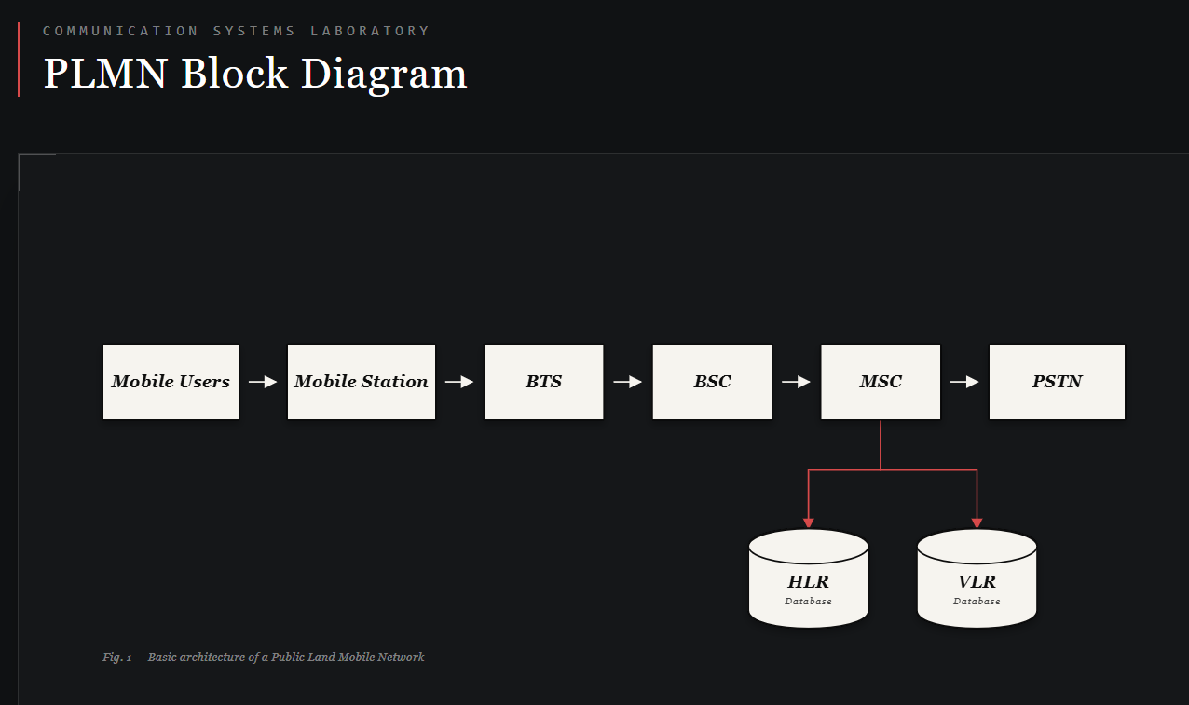
https://www.figma.com/make/SGn49GUC7FeRVDk5RIsUcY/EXPERIMENT-8?t=q4ehJPQngmonsvrw-0
Result: Thus, an infographic explaining the structure and functions of PLMN was created successfully using Figma.

